India-Pakistan Conflict
Student’s Name
Institutional Affiliation
Date

India-Pakistan Conflict
Introduction
India-Pakistan conflict is also called the Kashmir conflict, and it is a territorial conflict between India and Pakistan over the Kashmir region. This conflict can be traced back in 1947 after the partition of India as a dispute over the former princely state of Jammu and Kashmir. This dispute has escalated into three wars between these countries with China also being involved in the conflicts. Both Pakistan and India claim the entirety of the former princely state of Kashmir and Jammu. India claims the entire sovereign state of Kashmir and Jammu based on an Instrument of Accession signed in 1947 while Pakistan claims Jammu and Kashmir based on its majority Muslim population. China, on the other hand, claims the Shaksam Valley and Aksa Chin (Ganguly, 2002).
The Indo-Pakistan conflict stems from both religious differences between the Muslims and Hindus and the economic welfare of the nations. The other source of disagreement between the two countries is territorial ownership of Jammu and Kashmir. Since the formation of the Indian and Pakistani governments in 1947, thousands of Pakistanis and Indians have died in the countless battles and three wars between the two countries. This paper explores the origins of the India-Pakistani conflict and how they have led to the escalating wars between the two nations. The paper identifies at least three roots of disagreement between the countries. These are religious reasons (Hindus and Muslims), the geographical location of the territory of Kashmir and Jammu and political reasons (the British rule).

Background to the Indian-Pakistan conflict
The Indian-Pakistan conflict dated back in 1947. This is the time when the British rule in the Indian subcontinent ended. This led to the creation of two states: the union of India and the Dominion of Pakistan. Consequently, the British Paramountcy over the 562 Indian Princely states came to an end (Schofield, 2010). These states were therefore left to choose between joining India or Pakistan or to remain independent. Hindu Maharaja Hari Singh ruled Kashmir and Jammu which were the largest of the princely states with a predominantly Muslim population. Maharaja who was a Hindu decided to independent because he feared that the Muslims in his country would be unhappy with accession to India and the Hindus and Sikhs would become vulnerable with accession to Pakistan. Since the people had been fighting for independence from the British rule, they were not willing to let the princes fill the vacuum left by the British rulers. Schofield (2010) argues that Hari Singh was unable to decide which nation to join and chose to remain neutral. The hopes of Hari Singh to remain independent were dashed in 1947 when Muslim tribesmen from Pakistan knocked at the gates of the capital Srinagar. This prompted Hari Singh to appeal for military assistance from India and signed the instrument of Accession, ceding Kashmir to India on October 26. India and Pakistan fought their first war in over Kashmir in 1947-1948. This set the stage for the series of battles and wars that would be fought for many years to come.
Religion as an origin of India-Pakistan conflict
Ganguly (2002) argues that religion is one of the primary cause of conflict between India and Pakistan. Muslims inhabit Pakistan while Hindus dominate India. The population of the Indian-administered state of Kashmir and Jammu comprises more than 60% Muslim, which makes it the only country within India where Muslims are the majority. It is the religious disputes that led to the decision for the partition of British India into the Islamic state of Pakistan (west) and the Islamic nation of Bangladesh (Pakistan) to the east which was mainly the Hindu nation of India. After the partition of India and Pakistan in 1947, the Pakistani was mainly a Muslim nation while Hindus dominated India. The problems arising in India and Pakistan can be attributed to the Hindu-Muslim row. Of all the religious issues in contemporary India, history has cast its shadow on Hindu-Muslim relations (Ganguly, 2002).
After the partition in 1947, a Muslim sovereign state of Pakistan was born amidst a lot of chaos but for some reasons, most of the Muslims stayed in India. The partition did not solve the Hindu-Muslim conflict, but rather it caused the situation of the Muslims waiting in India to deteriorate. The Muslims were blamed for the division of the country; their power was weakened by the removal of all Muslim-majority areas except Kashmir. The India-Pakistan conflict kept the roots of the communal tension perpetually alive. This pushed Muslims into the situation of defending their loyalty to India. Even after more than 3o years after independence, this problem has not been overcome, and the Hindu-Muslim riots have continued to exist.
In 1965, the conflict resumed and resulted in the second war between these two countries. The Pakistani Government believed that the majority of the Muslim state in Kashmir rightfully belonged to Pakistan. In August 1965, the clashes intensified as Pakistani Army attempted to take Kashmir by force. However, this attempt to seize Kashmir was unsuccessful, and this war reached a stalemate as the cold war complicated the situation. Therefore, religious differences between Pakistan and India is one of the origins of the Indian-Pakistani War. Ideally, religious beliefs are a significant aspect of any culture and is an essential factor for understanding the motivations and behavior of people. What one believes affects how that person behaves and understands the world. Religious beliefs is thus a significant factor underlying Indo-Pakistani conflicts. Hinduism and Islam are two different religions and whose viewpoints cannot be reconciled in any way. Since the religious tenets are intrinsically different, it has proven to be incredibly impossible for the Hindus and Muslims to be compatible in their thinking and hence behavior.
The geographical location of Kashmir and Jammu a source of Indian-Pakistan Conflict
The geographical location of Jammu and Kashmir is a significant source of conflict between India and Pakistan. The two countries have fought over the wealthy region of Kashmir. Should Kashmir be a part of India or Pakistan? To understand and answer this question, we dig deep into the history and geography of Jammu and Kashmir. Geographically, Kashmir is found to the northern part of the Indian subcontinent. Until the 19th century, Kashmir denoted only the Kashmir valley between the Himalayas and the Panjal Range, but today it indicates a more substantial area which includes the Indian administered territory of Jammu and Kashmir (Paul & Paul, 2005).
India claims Jammu, Ladakh and Kashmir Valley as her territories while Pakistan claims Azad Kashmir and Gilgit-Baltistan. The Chinese also have a hand in Kashmir, and it claims Aksai Chin and the Trans-Karakoram Tract. Therefore, each of these three countries claims a part or two of the Kashmir which has been a primary cause of conflict especially between Pakistan and India (Paul & Pau, 2005).
The conflict between India and Pakistan is essentially a territorial one especially following the partition of India in 1947 as a dispute over the former princely state of Kashmir and Jammu (Schofield, 2010). The first war between the two countries which were fought in 1947. After the British rule ended in 1947, Kashmir and Jammu, the two primary states were left to choose whether to join Pakistan or India. After the first war between Pakistan and India in 1947-48, India referred the dispute to the United Nations. In August 13, 1948, the United Nations asked Pakistan to withdraw its troops from India. Once this happened, a free and fair Plebiscite was held which allowed the Kashmir people to decide their future. India was confident of winning a referendum because it had the support of Sheikh Abdullah, the leader of Kashmir. This led to the formation of an emergency government on October 30, 1948, with sheik Abdullah as the prime minister. Pakistan ignored the United Nations mandate and continued fighting, holding onto the portion of Kashmir under control. A compromise was struck in 1949 with 65% of the territory under Indian control and the remaining 35% with Pakistan. Although the ceasefire was intended to be temporary, the Line of Control remains the de facto border between the two states (Schofield, 2010).
In 1957, Kashmir became formally incorporated into the Indian Union and granted special status under Article 370 of India's constitution which prohibits non-Kashmir Indians from buying property there. Another fight broke in 1956, but a ceasefire was established that September. The clashes continued in years to come. Therefore, the geographical location of Kashmir has contributed to the many wars that have been fought between India and Pakistan. Both of them want a more substantial portion if not the whole of Kashmir to cede into their territories. This is why the Indian-Pakistan war is also called the Kashmir war conflict which is a territorial conflict over the Kashmir region. India-Pakistan conflict is, therefore, a border conflict over Kashmir (Mohan, 1992).
From the map shown below, Kashmir is bordered by three countries, India to the south, China to the East and Northeast and Pakistan to the West. Its location between these countries makes it difficult for one to determine where Kashmir should be annexed to objectively and it were to be which country would get what amount of share. Due to this location of Kashmir, the Indians, Pakistanis, and Kashmir have differing views and stands. Each of them wants full control of Kashmir.

Map showing the geographical location of Kashmir and Jammu and its neighbors, Pakistan, India and China and the Line of Control
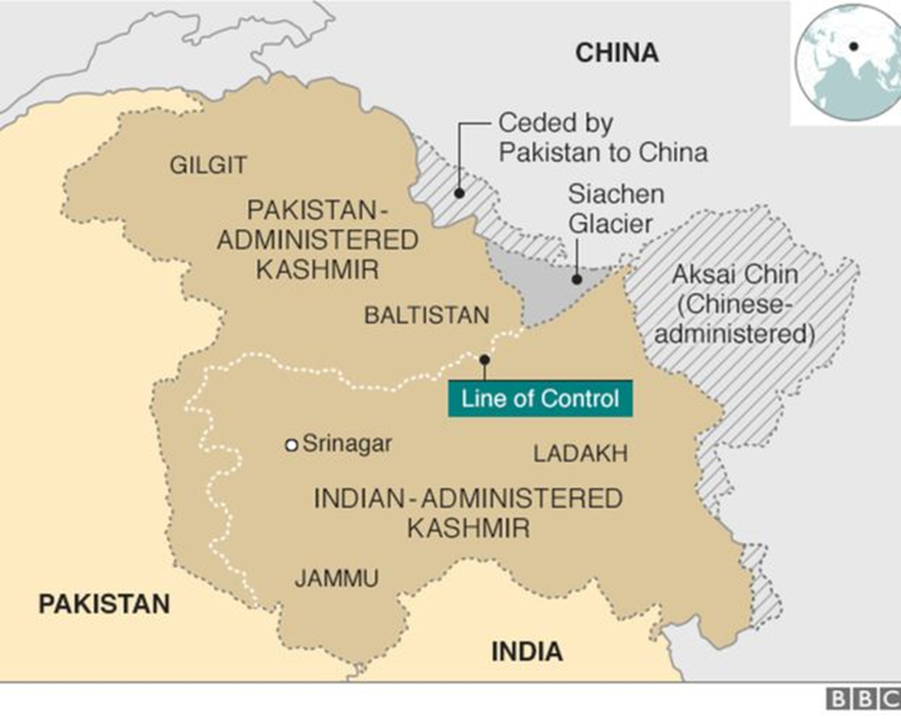

The differing views of India and Pakistan over Kashmir
Indian perspective
India believes that Kashmir is an integral part of India. India holds that the Instrument of Accession of the state of Kashmir and Jammu to the Union of India which was signed by Hari Singh in 1947, was a legal act and valid, and it is irrevocable. This means that India claims the full ownership of Kashmir and Jammu, a decision which was made by the Leader of Kashmir in 1947 (Maharaja Hari Singh). If this is held valid and affected, then it would mean that India has full control of Kashmir and Jammu (Mohan, 1992).
Secondly, India holds that the state of Jammu and Kashmir was provided with significant autonomy under the constitution of India. Under Article 30 of the Indian constitution, the state of Jammu and Kashmir are given freedom. Also, India does not accept the two-nation theory. This theory is the one that forms the basis for Pakistan's claims. It considers Kashmir, despite being a Muslim majority state is in many ways an integral part of India. India refutes this theory because, most of the population in Kashmir are Muslims while those in India are Hindus, and thus Pakistan which is a Muslim dominated country would be favored to occupy Kashmir. These two viewpoints make India believe that Kashmir and Jammu are their states and should not relent in pursuing their interest to occupy them (Mohan, 1992).
Pakistan View
Pakistan too has its claims as to why it should occupy Jammu and Kashmir. Pakistan maintains that Kashmir is the "Jugular vein of Pakistan" and that the people of Kashmir must decide the final status. Pakistan rejects India's claims to Kashmir which is the Instrument of Accession which was signed by Maharaja in 1947. Pakistanis maintain that Maharaja was not a popular leader and was referred to as a tyrant by many Kashmiris. Pakistan also holds that due to the popular Kashmiri insurgency, the Kashmiri people no longer wish to remain in India. Pakistan thus concludes that Kashmir to either stay independent or join Pakistan (Mailk, 2002).
Secondly, Pakistan defends the two-nation theory which India strongly rejects. According to this theory, Kashmir should remain with Pakistan since it has a Muslim majority, unlike India whose population is dominated by Hindus.
The role of British Rule on India-Pakistan conflict
The British have a hand in the India-Pakistan battle. The disputes between India and Pakistan can be traced in 1947 when the British left the region. The Kashmiris were confused about the step to make. They were to choose whether to join India or Pakistan or remain independent. Actually, the first political fight within the region was led by an Indian movement who attempted to remove the British Imperialist rule from the Indian Subcontinent. Therefore, when the British finally left, India felt that it was the one who was responsible for driving away from the British Imperialists and hence had a legal right over Kashmir. India felt that its effort to drive away the British had to be appreciated. It was Indian revolutionaries who terrorized the British institutions and confronted the British military. The Indian revolutionaries were the ones fighting for independence from the British rulers (Bose, 2009) and hence they felt they had to control Kashmir after the departure of the British Imperialists.

Current Status of India-Pakistan Conflict
After Indian Prime Minister Modi took power in 2014, there was hope that there would be meaningful peace negotiations between India and Pakistan. This was after Nawaz Sharif the Pakistan prime minister was invited to attend Modi inauguration. This has been the case as the situation changed to be sour in August 2014 when India canceled talks with foreign affairs minister. The cancelation was as a result of Pakistan high commissioner based in India met “Kashmiri separatist group, a group that wants separation of Kashmir from India. India opened negotiations with Pakistan since then in 2015 including some unscheduled meeting like the December 2015 meeting during the united nation conference on climate change in Paris. This was followed by a meeting of national security advisors that was held in Bangkok. In December the same year, Modi made a surprise visit to Lahore where he met Pakistan Prime Minister Sharif (Ganguly et l., 2019).
Series of peace talks were held, but the Uri army base attack by armed militants in September 2016 brought the negotiations to a standstill. The attack killed 18 Indian soldiers which were termed as the worst attack on the Indian forces for more than a decade. Later in the month, Indian troops declared to have attacked terrorist camp inside Pakistan, but Pakistan military dismissed such allegations. October 2017, militants attacked Indian paramilitary camp and in 2018 an army base. The attacks were near Srinagar and Jammu region respectively. Following this incident protest and violent demonstration occurred that were calling for the independence of Kashmir. Indian military carried out operations in the area that were targeting demonstrations and Kashmir militants. In May 2018, India announced to cease fire on Kashmir over the month of Ramadan and resumed operation in June 2018. May 2018, India and Pakistan signed cease-fire that restored the 2003 agreement.
The tension between the two states has escalated sharply in 2019. This is after a militant suicide attack on Indian paramilitary convoy in Kashmir that claimed 42 Indian military soldiers on 14th February 2019. Pakistan based militant, Jaish-e-Mohammad claimed to have carried out the attack. This has forced India to declare Pakistan is using militants to destabilize the Indian administered part of Kashmir. Pakistan denied the incident. Twelve days following the attack, the two states placed airstrikes against each other. India carried out the first air strike in the early morning of 26th February 2019 in Balakot town, Khyber Pakhtunkhwa province of Pakistan. Pakistan military was the first to announce the attack, but India confirmed the strike later the same day claiming it was directed to terrorist camps. Pakistan conducted the second retaliatory strike on 27th February in the Indian administered Kashmir. The aerial battle was done during the airstrike that caused the shooting of Indian MiG-21. This is warplane that was owned by India but designed by Mikoyan-Gurevich, a Soviet Union designer, its pilot Abhinandam Varthaman was captured as a prisoner of war by Pakistan military. Analysis carried later about the two airstrikes, concluded that there were no significant targets that India made on jab hilltop site. This was confirmed by an international journalist who visited the area under tight security from Pakistan. The site did not any evidence of damage or rebuilding going on. Abhinandam was returned to India on the 1st march (Ganguly et al., 2019)
The month of March witnessed improvements in the conflict. With the return of Indian army pilot, many citizens lined up to welcome him, but Pakistan foreign minister boycotted a meeting organized by Islamic cooperation that weekend. This was because his counterpart from India was invited. Also, the same day Pakistan re-opened her closed airspace. Modi, the Indian prime minister, pledged strict action on terror. 2nd March, India, and Pakistan are requested to talk and use peaceful means to tackle their difference by the Global Muslim Body. Also, India submitted bodies of Pakistan citizens killed in 26th battle. On March 9th, India requested Pakistan to crackdown all terror group to avoid new fighting. Pakistan responded to the required by commencing the crackdown on the militants (Ganguly et al., 2019).
Conclusion
To sum it up, the Indian-Pakistan conflict also called the Kashmir conflict is essentially a conflict whose origin can be attributed to three factors namely: religious differences between Pakistanis (Muslims) and Indians (Hindus), the geographical location of Kashmir and the British rule. The conflict can be traced way back in 1947 the partition of India as a dispute over the former princely state of Jammu and Kashmir. This was also the time when the British rulers ceased to exercise power over the Indian subcontinent which led to the creation of two states: the union of India and the Dominion of Pakistan. Since then, there have been endless conflicts between India and Pakistan for over fifty years with the latest attack taking place in February 2019. The fight is based on the ownership of the territory of Jammu and Kashmir which is bordered by the two countries plus China which also claims a share (Ganguly et al., 2019).
Both India and Pakistan have their views and rationale as to why Kashmir should be part of their territories. After the British had left, Kashmir had the choice of either joining Pakistan or India or remaining independent. The then ruler of Kashmir, Maharaja decided to join India upon signing of the Instrument of Accession. The Instrument of Accession signed in 1947 by this ruler would become India's tool of defense to claim the ownership of Kashmir. However, Pakistan refutes the Instrument of Accession and claims that since the majority of the population in Kashmir are Muslims, then Kashmir should be its territory based on religious affiliation.
The conflict is still on, and there are no signs of its end. The current status of the conflict does not promise a good future. The situation seems to worsen in the future (Bose, 2009). The recent attacks have escalated in 2019 after a militant suicide attack on Indian paramilitary convoy in Kashmir that claimed 42 Indian military soldiers on 14th February which shows how the situation could worsen in the future although improvements have been made in March.

References
Bose, S. (2009). Kashmir: Roots of conflict, paths to peace. Harvard University Press.
Ganguly, Š. (2002). Conflict Unending: India-Pakistan Tensions since 1947. Columbia University Press.
Ganguly, S., Smetana, M., Abdullah, S., & Karmazin, A. (2019). India, Pakistan, and the Kashmir dispute: unpacking the dynamics of a South Asian frozen conflict. Asia Europe Journal, 17(1), 129-143.
Mailk, M. (2002). The China factor in the India-Pakistan conflict. ASIA-PACIFIC CENTER FOR SECURITY STUDIES HONOLULU HI.
Mohan, A. (1992). The historical roots of the Kashmir conflict. Studies in Conflict & Terrorism, 15(4), 283-308.
Paul, T. V., & Paul, T. V. (Eds.). (2005). The India-Pakistan conflict: an enduring rivalry. Cambridge University Press.
Schofield, V. (2010). Kashmir in conflict: India, Pakistan and the unending war. Bloomsbury Publishing.

